Artificial Intelligence (BAD402)

MODULE-1

Overview of Artificial Intelligence:
Artificial Intelligence is concerned with the design of intelligence in an artificial device. The term was coined by John McCarthy in 1956.
Intelligence is the ability to acquire, understand and apply the knowledge to achieve goals in the world.
AI is the study of the mental faculties through the use of computational models
AI is the study of intellectual/mental processes as computational processes. AI program will demonstrate a high level of intelligence to a degree that equals or exceeds the intelligence required of a human in performing some
task.
AI is unique, sharing borders with Mathematics, Computer Science, Philosophy, Psychology, Biology, Cognitive Science and many others.
Although there is no clear definition of AI or even Intelligence, it can be described as an attempt to build machines that like humans can think and act, able to learn and use knowledge to solve problems on their own.

Definitions of AI
Thinking humanly-Machine with minds. It is an effort to make computers think. It involves automation of human activities such as decision making, problem solving and learning
Thinking rationally- Machine with models. It is The study of the computations that make it possible to perceive, reason, and act.
Acting humanly -Create machines working as people. The study of how to make computers do things at which, at the moment, people are better
Acting rationally - Computational Intelligence is the study of the design of intelligent agents.

Acting humanly:
A machine passes Turing Test if human interrogator cannot differentiate whether responses came from human or machine. To pass Turing test, machine requires:
Natutal Langauge processing: To enable it to communicate successfully in English; Knowledge representation to store what it knows or hears;
Automated reasoning to use the stored information to answer questions and to draw new conclusions;
machine learning to adapt to new circumstances and to detect and extrapolate pattern

Total Turing Test
In the Total Turing Test, verbal behaviors are not the sole standard for intelligence: other behaviors are examined too. “‘The candidate must be able to do, in the real world of objects and people, everything that real people can do”. Total Turing Test can only be applied to a robot, or some other agent that is

situated and embodied in the physical world. To pass the total Turing Test, the computer will need:
computer vision to perceive objects, and
robotics to manipulate objects and move about

Thinking humanly-Cognitive modeling approach:
Thinking humanly is to make a system or program to think like a human. But to achieve that, we need to know how does a human thinks. Suppose if we ask a person to explain how his brain connects different things during the thinking process, he/she will probably close both eyes and will start to check how he/she thinks but he/she cannot explain or interpret the process.
For example – If we want to model the thinking of Roger Federer and make the model system to compete with someone or against him to play in a tennis game, it may not be possible to replicate the exact thinking as Roger Federer, however, a good build of Intelligence systems (Robot) can play and win the game against him.
To understand the exact process of how we think, we need to go inside the human mind to see how this giant machine works. We can interpret how the human mind thinks in theory, in three ways as follows:
- Introspection method – Catch our thoughts and see how it flows.
- Psychological Inspections method – Observe a person on the action.
- Brain Imaging method (MRI (Magnetic resonance imaging) or fMRI (Functional Magnetic resonance imaging) scanning) – Observe a person’s brain in action.

Thinking rationally-Laws of thought approach:
Aristotle’s syllogisms provided patterns for argument structures that always provide correct premises.A famous example, “Socrates is a man; all men are mortal; therefore, Socrates is mortal”. Another example – All TVs use energy; Energy always generates heat; therefore, all TVs generate heat”.
These arguments initiated the field called logic. Notations for statements for all kinds of objects were developed and interrelated between them to show logic. By 1965, programs existed that could solve problems that were described in logical notation and provides a solution.
There are two limitations to this approach:
- First, it is not easy to take informal knowledge to use logical notation when there is not enough certainty on the knowledge.
- Solving in principle and solving in practice varies hugely.

Acting rationally-Rational Agent approach:
A traditional computer program blindly executes the code that we write. Neither it acts on its own nor it adapts to change itself based on the outcome. The so- called agent program that we refer to here is expected to do more than the traditional computer program. It is expected to create and pursue the goal, change state, and operate autonomously.
A rational agent is an agent that acts to achieve its best performance for a given task. The “Logical Approach” to AI emphasizes correct inferences and achieving a correct inference is a part of the rational agent. Being able to give a logical reason is one way of acting rationally. But all correct inferences cannot be called rationality, because there are situations that don’t always have a correct thing to do. It is also

possible to act rationally without involving inferences. Our reflex actions are considered as best examples of acting rationally without inferences.
The rational agent approach to AI has a couple of advantage over other approaches:
- A correct inference is considered a possible way to achieve rationality but is not always required to achieve rationality.
- It is a more manageable scientific approach to define rationality than others that are based on human behavior or human thought.

Foundations of Artificial Intelligence:

Philosophy
Idealism is the belief that the mind and ideas is the primary structure of reality and that physical or material reality is secondary.
Materialism is the opposite of Idealism and sees matter as the primary reality and all other things including thoughts as the product of interactions of matter.
Rationalism is the belief that the rational mind is the best way to know something. If you are a rationalist you believe that your mind is more trustworthy than your sense. A stick in the water might look bent, but you know rationally that it only looks that way because it is in the water.
Empiricism is the opposite of rationalism and it is the belief that the senses are the best way to know something. You might think something is true, but you only know it is true if your senses confirm it.
The principle of induction, as applied to causation, says that, if A has been found very often accompanied or followed by B, then it is probable that on the next occasion on which A is observed, it will be accompanied or followed by B.
Logical positivism is a combination of the two approaches upheld by positivism and symbolic logic. Positivism is a particular school of knowledge which advocates that valid knowledge must be based on sense knowledge. Any knowledge which is not based on senses is meaningless. It could be noted here that positivism is the extreme form of empiricism as the empiricists do not claim that knowledge not based on senses is invalid or meaningless, though they too advocate that knowledge should begin with sense experience

Mathematics
Philosophers staked out some of the fundamental ideas of AI, but the leap to a formal science required a level of mathematical formalization in three fundamental areas: logic, computation, and probability
In mathematics and computer science, an algorithm is a finite sequence of rigorous instructions, typically used to solve a class of specific problems or to perform a computation. Algorithms are used as specifications for performing calculations and data processing
Incompleteness theorem states that in any reasonable mathematical system there will always be true statements that cannot be proved.
Computable functions are the formalized analogue of the intuitive notion of algorithms, in the sense that a function is computable if there exists an algorithm that can do the job of the function, i.e. given an input of the function domain it can return the corresponding output.
Tractable problems can be solved by computer algorithms that run in

polynomial time; i.e., for a problem of size n, the time or number of steps needed to find the solution is a polynomial function of n. Algorithms for solving hard, or intractable, problems, on… In P versus NP problem.

Economics
In economics, utility is a term used to determine the worth or value of a good or service. More specifically, utility is the total satisfaction or benefit derived from consuming a good or service. Economic theories based on rational choice usually assume that consumers will strive to maximize their utility.
Both decision and game theory concern the reasoning process underlying people’s choices, that is, how their desires, beliefs, and other attitudes combine in a way that make people choose one option over another.
Whereas decision theory is concerned with an individual decision-maker who tries to make the best decision based on their understanding of the world, game theory is concerned with the interaction between different decision-makers each of whom is trying to make the best decision based on their beliefs about what others will choose.
A Markov decision process (MDP) refers to a stochastic decision-making process that uses a mathematical framework to model the decision-making of a dynamic system. It is used in scenarios where the results are either random or controlled by a decision maker, which makes sequential decisions over time.
Satisficing is a decision-making strategy that aims for a satisfactory or adequate result, rather than the optimal solution. Instead of putting maximum exertion toward attaining the ideal outcome, satisficing focuses on pragmatic effort when confronted with tasks.

Neuroscience
Neuroscience is the study of the nervous system – from structure to function, development to degeneration, in health and in disease. It covers the whole nervous system, with a primary focus on the brain. Incredibly complex, our brains define who we are and what we do. They store our memories and allow us to learn from them. Our brain cells and their circuits create new thoughts, ideas and movements and reinforce old ones. Their individual connections (synapses) are responsible for a baby’s first steps and every record-breaking athletic performance, with each thought and movement requiring exquisitely precise timing and connections.

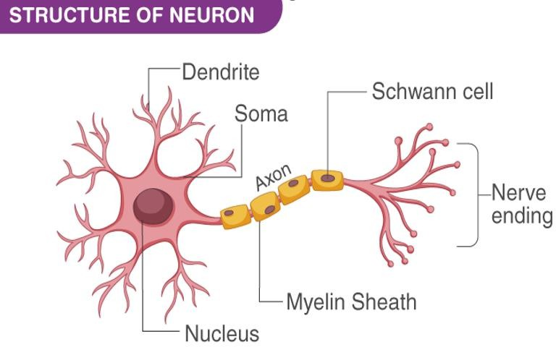

Neurons (also called neurones or nerve cells) are the fundamental units of the brain and nervous system, the cells responsible for receiving sensory input from the external world, for sending motor commands to our muscles, and for transforming and relaying the electrical signals at every step in between. More than that, their interactions define who we are as people. A neuron has three main parts: dendrites, an axon, and a cell body or soma (see image below), which can be represented as the branches, roots and trunk of a tree, respectively. A dendrite (tree branch) is where a neuron receives input from other cells. Dendrites branch as they move towards their tips, just like tree branches do, and they even have leaf-like structures on them called spines.
A crude comparison of the raw computational resources available to the IBM BLUE GENE supercomputer, a typical personal computer of 2008, and the human brain.

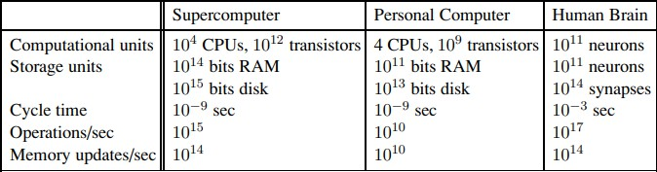

Psychology
Psychology is the scientific study of the mind and behavior. Psychologists are actively involved in studying and understanding mental processes, brain functions, and behavior. The field of psychology is considered a "Hub Science" with strong connections to the medical sciences, social sciences, and education
Cognitive psychology is the branch of psychology dedicated to studying how people think. The cognitive perspective in psychology focuses on how the interactions of thinking, emotion, creativity, and problem-solving abilities affect how and why you think the way you do. Cognitive psychology attempts to measure different types of intelligence, determine how you organize your thoughts, and compare different components of cognition.
three key steps of a knowledge-based agent: (1) the stimulus must be translated into an internal representation, (2) the representation is manipulated by cognitive processes to derive new internal representations, and (3) these are in turn retranslated back into action

Computer Engineering
Computer engineering is defined as the discipline that embodies the science and technology of design, construction, implementation, and maintenance of software and hardware components of modern computing systems and computer-controlled equipment.
Computer engineering has traditionally been viewed as a combination of both computer science (CS) and electrical engineering (EE).
It has evolved over the past three decades as a separate, although intimately related, discipline.
Computer engineering is solidly grounded in the theories and principles of computing, mathematics, science, and engineering and it applies these theories and principles to solve technical problems through the design of computing hardware, software, networks, and processes.
Increasingly, computer engineers are involved in the design of computer-based systems to address highly specialized and specific application needs.
Computer engineers work in most industries, including the computer, aerospace, telecommunications, power production, manufacturing, defense, and electronics industries.

Control Theory and Cybernetics
Control theory (Goodwin et al., 2001) deals with influencing the behavior of dynamical systems. Although a major application of control theory involves control system engineering, which deals with the design of process control systems for industry, other applications range far beyond this. This section presents the basic principles for modeling a dependable system as a control system.
Cybernetics (Wiener, 1948), control theory, is a transdisciplinary branch of engineering and computational mathematics. It deals with the behavior of dynamical systems with inputs and how their behavior is modified by feedback.
The objective of control theory is to control a system so that the system's output follows a desired control signal, called the reference. To do this, a (normally

feedback) controller is designed that determines what output needs to be monitored, how to compare it with the reference, which system behaviors need to be adjusted, and how to adjust them. The difference between actual and desired output, called the error signal, is applied as feedback to the system input, to bring the actual output closer to the reference.

Linguistics
Linguistics is the scientific study of language, and its focus is the systematic investigation of the properties of particular languages as well as the characteristics of language in general.
It encompasses not only the study of sound, grammar and meaning, but also the history of language families, how languages are acquired by children and adults, and how language use is processed in the mind and how it is connected to race and gender.
With close connections to the humanities, social sciences and the natural sciences, linguistics complements a diverse range of other disciplines such as anthropology, philosophy, psychology, sociology, biology, computer science, health sciences, education and literature.
The subfield of Applied Linguistics emphasizes the use of linguistic concepts in the classroom to help students improve their ability to communicate in their native language or a second language.

HISTORY OF AI

The gestation of artificial intelligence (1943–1955)
Knowledge of basic psychology, functions of neurons in the brain and propositional logic
A neural network is a neural circuit of biological neurons, sometimes also called a biological neural network, or a network of artificial neurons or nodes in the case of an artificial neural network.[1]
Artificial neural networks are used for solving artificial intelligence (AI) problems; they model connections of biological neurons as weights between nodes. A positive weight reflects an excitatory connection, while negative values mean inhibitory connections. All inputs are modified by a weight and summed.
Neuron on or off based on stimulation by neighboring neurons
Simple neural network with logical connectives like AND, OR, NOT etc
Hebbian Learning attempts to connect the psychological and neurological underpinnings of learning. he basis of the theory is when our brains learn something new, neurons are activated and connected with other neurons, forming a neural network. These connections start off weak, but each time the stimulus is repeated, the connections grow stronger and stronger, and the action becomes more intuitive.

The birth of artificial intelligence (1956)
he field of Artificial Intelligence (AI) was officially born and christened at a workshop organized by John McCarthy in 1956 at the Dartmouth Summer Research Project on Artificial Intelligence. The goal was to investigate ways in

which machines could be made to simulate aspects of intelligence.
Although the Dartmouth workshop created a unified identity for the field and a dedicated research community, many of the technical ideas that have come to characterize AI existed much earlier.
In the eighteenth century, Thomas Bayes provided a framework for reasoning about the probability of events.
George Boole showed that logical reasoning—dating back to Aristotle— could be performed systematically in the same manner as solving a system of equations.
Emergence of the field of statistics, which enables inferences to be drawn rigorously from data.
The idea of physically engineering a machine to execute sequences of instructions, which had captured the imagination of pioneers such as Charles Babbage, had matured by the 1950s, and resulted in the construction of the first electronic computers.
Primitive robots, which could sense and act autonomously, had also been built by that time.

Why AI as a separate branch
- AI to duplicate human facilities such as creativity, self-improvement and language use
- Uses computer science methodologies
- Design autonomous systems

Early enthusiasm, great expectations (1952–1969)
A physical symbol system takes physical patterns (symbols), combining them into structures (expressions) and manipulating them (using processes) to produce new expressions.
Eg:
- Formal logic
- Algebra
- Chess
- Computer program
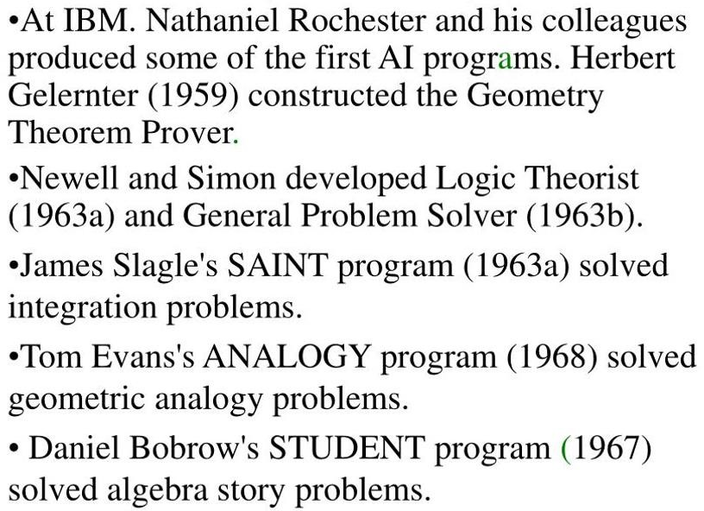

Lisp, an acronym for list processing, is a functional programming language that was designed for easy manipulation of data strings. As one of the oldest programming languages still in use, Lisp offers several different dialects and has influenced the development of other languages.
A unique feature of early Lisp versions compared to most other programming languages is that the code could be directly interpreted without a compiler. The source code itself could be parsed and interpreted directly on a system. Today, however, most Lisp versions require that code be compiled and then loaded into an image to run. This offers faster program execution speeds compared to direct interpretation.
To cope with the bewildering complexity of the real world, scientists often ignore less relevant details; for instance, physicists often ignore friction and elasticity in their models. In 1970 Marvin Minsky and Seymour Papert of the MIT AI Laboratory proposed that, likewise, AI research should focus on developing programs capable of intelligent behaviour in simpler artificial environments known as microworlds. Much research has focused on the so-called blocks world, which consists of coloured blocks of various shapes and sizes arrayed on a flat surface.

A dose of reality (1966–1973)
1960-70s
Too early for wide applications
Intractability issues: From a computational complexity stance, intractable problems are problems for which there exist no efficient algorithms to solve them. Most intractable problems have an algorithm – the same algorithm – that provides a solution, and that algorithm is the brute-force search.
The genetic algorithm is a method for solving both constrained and unconstrained optimization problems that is based on natural selection, the process that drives biological evolution. The genetic algorithm repeatedly modifies a population of individual solutions. Genetic algorithms also faced intractability
When training a neural network, there’s going to be some data that the neural network trains on, and there’s going to be some data reserved for checking the performance of the neural network. If the neural network performs well on the data which it has not trained on, we can say it has generalized well on the given data. Generalization of neural networks did not work

Knowledge-based systems: The key to power? (1969–1979)
DENDRAL, an early expert system, developed beginning in 1965 by the artificial intelligence (AI) researcher Edward Feigenbaum and the geneticist Joshua Lederberg, both of Stanford University in California. Heuristic DENDRAL (later shortened to DENDRAL) was a chemical-analysis expert system.
The substance to be analyzed might, for example, be a complicated compound of carbon, hydrogen, and nitrogen. Starting from spectrographic data obtained from the substance, DENDRAL would hypothesize the substance’s molecular structure.
DENDRAL’s performance rivaled that of chemists expert at this task, and the program was
used in industry and in academia.
An expert system is a computer program that is designed to solve complex problems and to provide decision-making ability like a human expert. It performs this by extracting knowledge from its knowledge base using the reasoning and inference rules according to the user queries.

The expert system is a part of AI, and the first ES was developed in the year 1970, which was the first successful approach of artificial intelligence. It solves the most complex issue as an expert by extracting the knowledge stored in its knowledge base. The system helps in decision making for compsex problems using both facts and heuristics like a human expert.
It is called so because it contains the expert knowledge of a specific domain and can solve any complex problem of that particular domain. These systems are designed for a specific domain, such as medicine, science, etc.
MYCIN was an early backward chaining expert system that used AI to identify microorganisms causing severe diseases like bacteremia and meningitis and propose antibiotics based on patient weight.

AI becomes an industry (1980–present)
It has taken more than 25 years to gain recognition from the industry. Xcon was the very first industrial application of AI. Xcon is an expert system that configures mini-computers to meet user requirements. That process was normally taken 8 hours but xcon did it within 8 minutes.
The neural network was reborn with a backpropagation training algorithm. In the late 1980s AI-based weapons were demonstrated. The best example of that is the DART expert system which is used in the gulf war.

AI adopts the scientific method (1987–present)
The field of speech recognition illustrates the pattern. In recent years, approaches based on hidden Markov models (HMMs) have come to dominate the area. Two aspects of HMMs are relevant. First, they are based on a rigorous mathematical theory. Second, they are generated by a process of training on a large corpus of real speech data. This ensures that the performance is robust, and in rigorous blind tests the HMMs have been improving their scores steadily.
Speech technology and the related field of handwritten character recognition are already making the transition to widespread industrial and consumer applications.
Machine translation follows the same course as speech recognition. Much of the work on neural nets in the 1980s was done in an attempt to scope out what could be done and to learn how neural nets differ from “traditional” techniques. Using improved methodology and theoretical frameworks, the field arrived at an understanding in which neural nets can now be compared with corresponding techniques from statistics, pattern recognition, and machine learning, and the most promising technique can be applied to each application.
Probabilistic Reasoning in Intelligent Systems led to a new acceptance of probability and decision theory in AI. The Bayesian network formalism was invented to allow efficient representation of, and rigorous reasoning with, uncertain knowledge.
Similar gentle revolutions have occurred in robotics, computer vision, and knowledge representation. A better understanding of the problems and their complexity properties, combined with increased mathematical sophistication, has led to workable research agendas and robust methods.

Agents and Environments
An agent is anything that can be viewed as perceiving its environment through sensors and SENSOR acting upon that environment through actuators. A human agent has eyes, ears, and other organs for sensors and hands, legs, vocal tract, and so on for actuators. A robotic agent might have cameras and infrared range finders for sensors and various motors for actuators. A software agent receives keystrokes, file contents, and network packets as sensory inputs and acts on the environment by displaying on the screen. Percept refers to the agent’s perceptual inputs at any given instant. An agent’s percept sequence is the complete history of everything the agent has ever perceived.
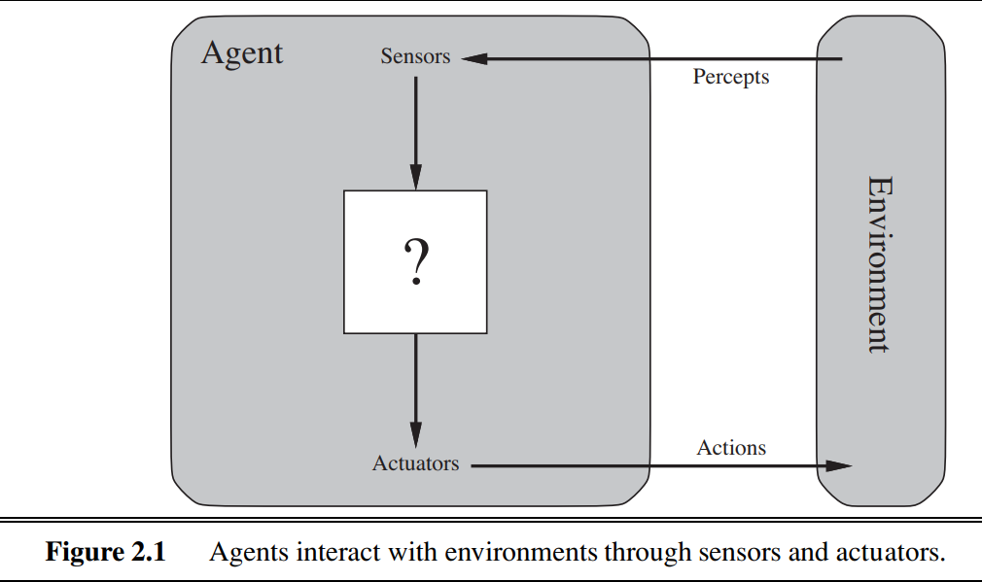

Agent function maps any given percept sequence to action. Agent program implements agent function in a physical system.

Eg: Vacuum cleaner for 2 locations
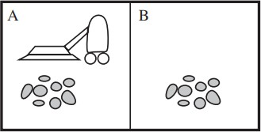

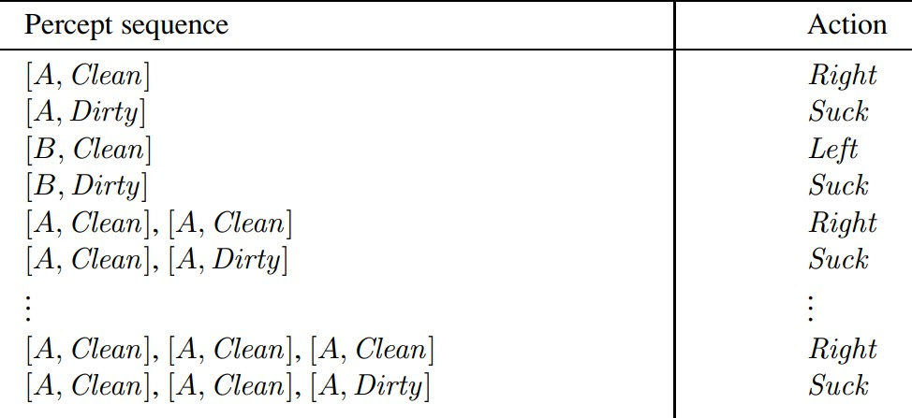

Rational Agents
A rational agent is a computer program that uses logical reasoning and the ability to make decisions to determine its following action. An excellent example of a rational agent is a chess player. A chess player can analyze the board and determine which moves will result in the most advantageous outcome for itself. It can move one piece over another, move its king out of danger, or attack an opponent's piece.
A rational agent has four primary characteristics:
- Perception: The ability to perceive the current state of the environment and gather relevant information.
- Actuators: The ability to take actions within the environment to achieve its goals.
- Performance measure: A way to evaluate the success or failure of the agent's actions.
- Rationality: The ability to make decisions based on logical reasoning and optimize behavior to achieve its goals, considering its perception of the environment and the performance measure.

PEAS
PEAS in AI is an acronym representing the foundational components that define an artificial intelligence agent's behavior. It stands for Performance Measure, Environment, Actuators, and Sensors.
Performance Measure refers to the criterion an AI agent uses to evaluate its actions; the environment encompasses the external context it operates within, Actuators are the mechanisms enabling the agent to interact with the environment, and Sensors provide the agent with the means to perceive and gather information.
PEAS serves as a structured approach to designing and understanding AI systems, aiding in conceptualizing objectives, interactions, and constraints. Whether applied to self-driving cars, virtual assistants, or medical diagnosis,

the PEAS framework offers a systematic lens to dissect and model AI's role within its surroundings.
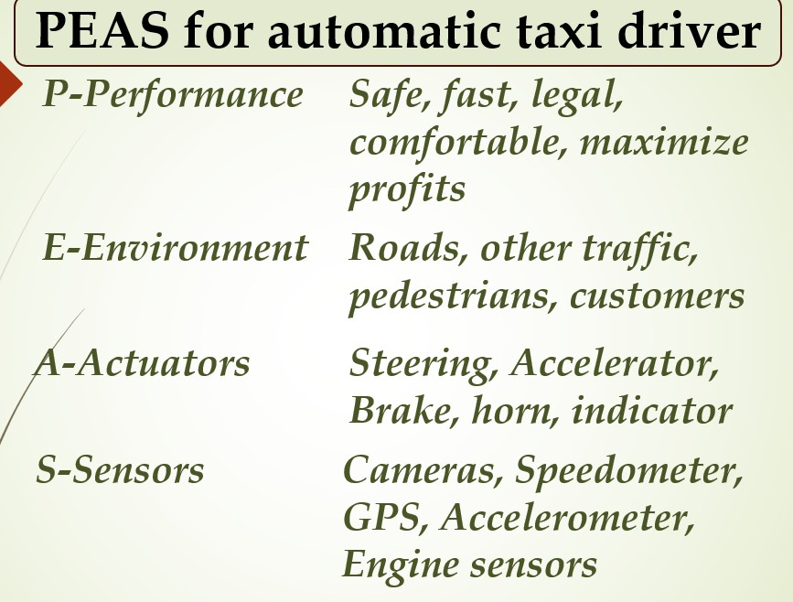

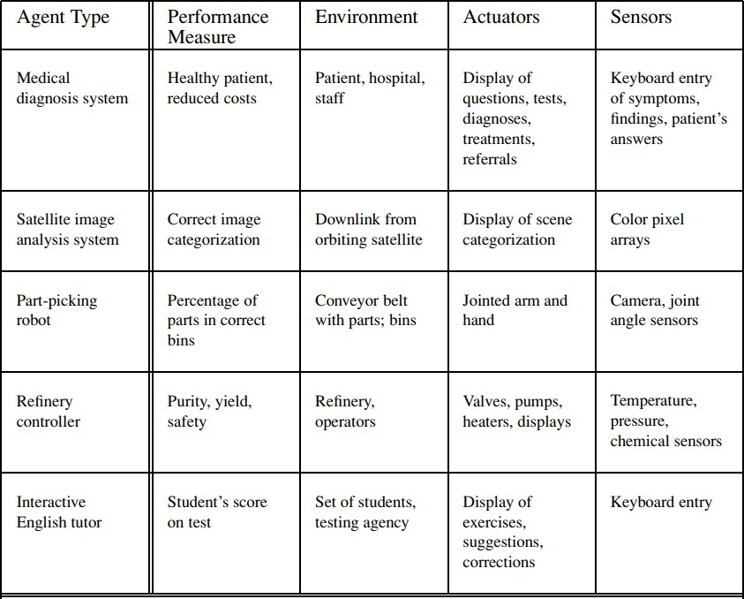

Types of Environments in AI
An environment in artificial intelligence is the surrounding of the agent. The agent takes input from the environment through sensors and delivers the output to the environment through actuators. There are several types of environments:
- Fully Observable vs Partially Observable
- Deterministic vs Stochastic
- Competitive vs Collaborative
- Single-agent vs Multi-agent
- Static vs Dynamic
- Discrete vs Continuous
- Episodic vs Sequential
- Known vs Unknown

Fully Observable vs Partially Observable
When an agent sensor is capable to sense or access the complete state of an agent at each point in time, it is said to be a fully observable environment else it is partially observable.
Maintaining a fully observable environment is easy as there is no need to keep track of the history of the surrounding.
An environment is called unobservable when the agent has no sensors in all environments.
Examples:
  - Chess – the board is fully observable, and so are the opponent’s
moves.
  - Driving – the environment is partially observable because what’s
around the corner is not known.

Deterministic vs Stochastic
When a uniqueness in the agent’s current state completely determines the next
state of the agent, the environment is said to be deterministic.
The stochastic environment is random in nature which is not unique and cannot be completely determined by the agent.
Examples:
  - Chess – there would be only a few possible moves for a coin at the current state and these moves can be determined.
  - Self-Driving Cars- the actions of a self-driving car are not unique, it varies time to time.

Competitive vs Collaborative
An agent is said to be in a competitive environment when it competes against another agent to optimize the output.
The game of chess is competitive as the agents compete with each other to win the game which is the output.
An agent is said to be in a collaborative environment when multiple agents cooperate to produce the desired output.

When multiple self-driving cars are found on the roads, they cooperate with each other to avoid collisions and reach their destination which is the output desired.

Single-agent vs Multi-agent
An environment consisting of only one agent is said to be a single-agent environment.
A person left alone in a maze is an example of the single-agent system.
An environment involving more than one agent is a multi-agent environment. The game of football is multi-agent as it involves 11 players in each team.

Dynamic vs Static
An environment that keeps constantly changing itself when the agent is up with some action is said to be dynamic.
A roller coaster ride is dynamic as it is set in motion and the environment keeps changing every instant.
An idle environment with no change in its state is called a static environment.
An empty house is static as there’s no change in the surroundings when an agent
enters.

Discrete vs Continuous
If an environment consists of a finite number of actions that can be deliberated in the environment to obtain the output, it is said to be a discrete environment.
The game of chess is discrete as it has only a finite number of moves. The
number of moves might vary with every game, but still, it’s finite.
The environment in which the actions are performed cannot be numbered i.e. is not discrete, is said to be continuous.
Self-driving cars are an example of continuous environments as their actions are driving, parking, etc. which cannot be numbered.

Episodic vs Sequential
In an Episodic task environment, each of the agent’s actions is divided into atomic incidents or episodes. There is no dependency between current and previous incidents. In each incident, an agent receives input from the environment and then performs the corresponding action.
Example: Consider an example of Pick and Place robot, which is used to detect defective parts from the conveyor belts. Here, every time robot(agent) will make the decision on the current part i.e. there is no dependency between current and previous decisions.
In a Sequential environment, the previous decisions can affect all future decisions. The next action of the agent depends on what action he has taken previously and what action he is supposed to take in the future.
Example:
Checkers- Where the previous move can affect all the following moves.

Known vs Unknown
In a known environment, the output for all probable actions is given. Obviously, in case of unknown environment, for an agent to make a decision, it has to gain knowledge about how the environment works.

Agent program
The task of AI is to design an agent program which implements the agent function. The structure of an intelligent agent is a combination of architecture and agent program. It can be viewed as:
Agent = Architecture + Agent program
Following are the main three terms involved in the structure of an AI agent:
Architecture: Architecture is machinery that an AI agent executes on.
Agent Function: Agent function is used to map a percept to an action.
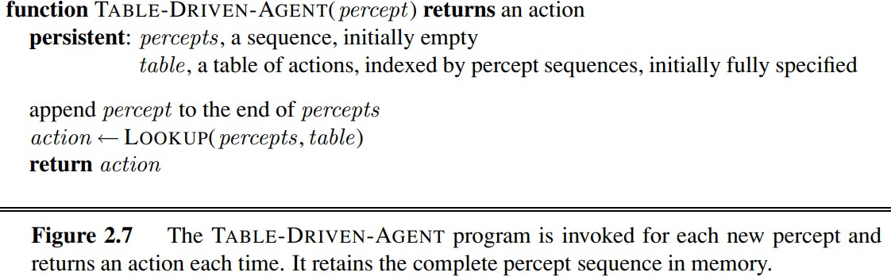

- Types of Agents in AI
Agents can be grouped into five classes based on their degree of perceived intelligence and capability. All these agents can improve their performance and generate better action over the time. These are given below:
- Simple Reflex Agent
- Model-based reflex agent
- Goal-based agents
- Utility-based agent
- Learning agent
- Simple Reflex agent:
  - The Simple reflex agents are the simplest agents. These agents take decisions on the basis of the current percepts and ignore the rest of the percept history.
  - These agents only succeed in the fully observable environment.
  - The Simple reflex agent does not consider any part of percepts history during their decision and action process.
  - The Simple reflex agent works on Condition-action rule, which means it maps the current state to action. Such as a Room Cleaner agent, it works only if there is dirt in the room.
  - Problems for the simple reflex agent design approach:
    - They have very limited intelligence
    - They do not have knowledge of non-perceptual parts of the current state
    - Mostly too big to generate and to store.
    - Not adaptive to changes in the environment.

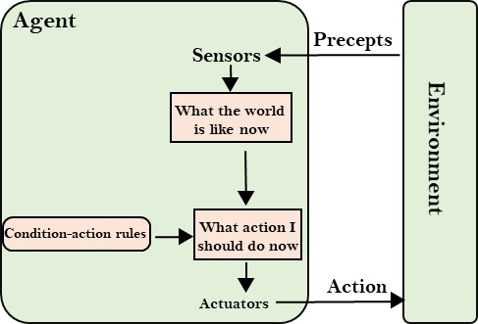
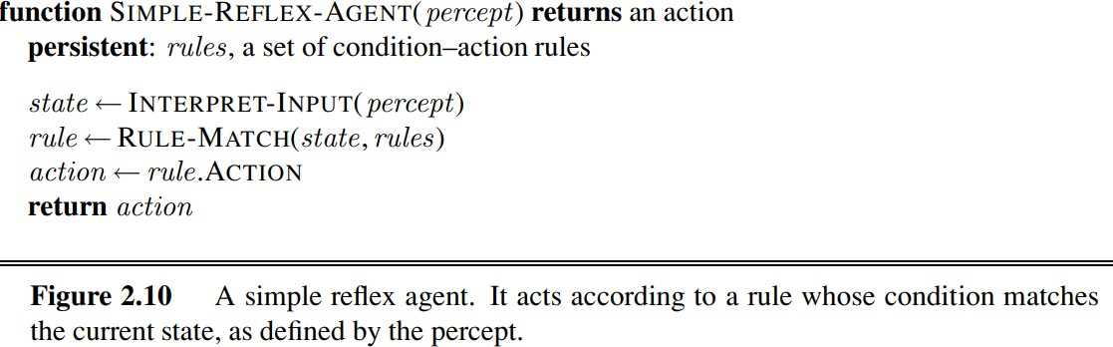
- Model-based reflex agent
  - The Model-based agent can work in a partially observable environment, and track the situation.
  - A model-based agent has two important factors:
    - Model: It is knowledge about "how things happen in the world," so it is called a Model-based agent.
    - Internal State: It is a representation of the current state based on percept history.
  - These agents have the model, "which is knowledge of the world" and based on the model they perform actions.
  - Updating the agent state requires information about:
    - How the world evolves
    - How the agent's action affects the world.

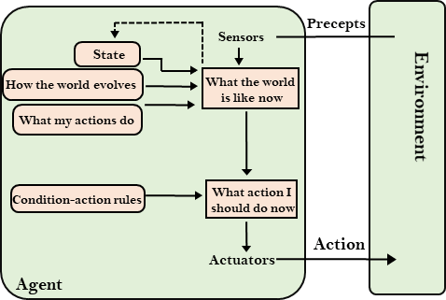
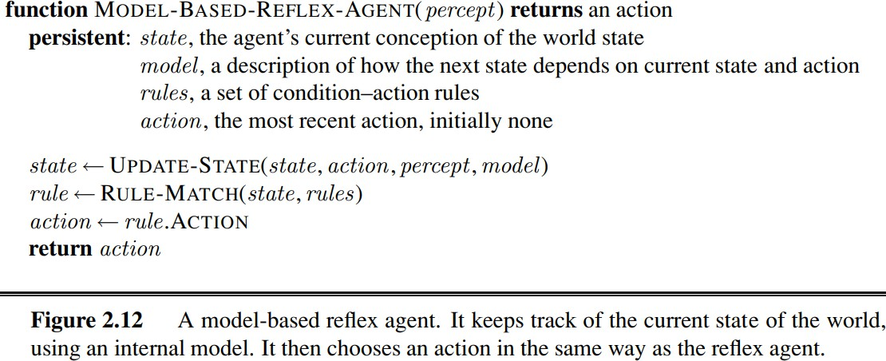

- Goal-based agents
  - The knowledge of the current state environment is not always sufficient to decide for an agent to what to do.
  - The agent needs to know its goal which describes desirable situations.
  - Goal-based agents expand the capabilities of the model-based agent by having the "goal" information.
  - They choose an action, so that they can achieve the goal.
  - These agents may have to consider a long sequence of possible actions before deciding whether the goal is achieved or not. Such considerations of different scenario are called searching and planning, which makes an agent proactive.

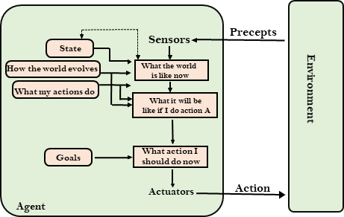

- Utility-based agents
  - These agents are similar to the goal-based agent but provide an extra component of utility measurement which makes them different by providing a measure of success at a given state.
  - Utility-based agent act based not only goals but also the best way to achieve the goal.
  - The Utility-based agent is useful when there are multiple possible alternatives, and an agent has to choose in order to perform the best action.
  - The utility function maps each state to a real number to check how efficiently each action achieves the goals.
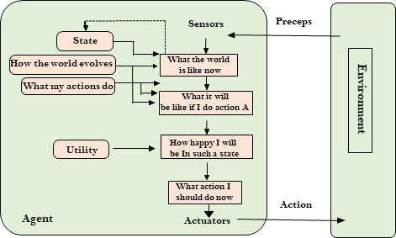

- Learning Agents
  - A learning agent in AI is the type of agent which can learn from its past experiences, or it has learning capabilities.
  - It starts to act with basic knowledge and then able to act and adapt automatically through learning.
  - A learning agent has mainly four conceptual components, which are:

- Learning element: It is responsible for making improvements by learning from environment
- Critic: Learning element takes feedback from critic which describes that how well the agent is doing with respect to a fixed performance standard.
- Performance element: It is responsible for selecting external action
- Problem generator: This component is responsible for suggesting actions that will lead to new and informative experiences.
  - Hence, learning agents are able to learn, analyze performance, and look for new ways to improve the performance.
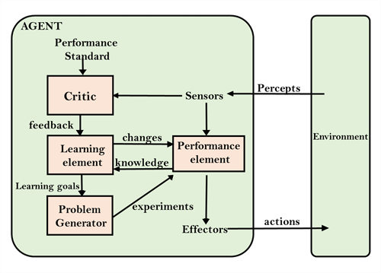

Agent components
Agents can be represented in three ways:
Atomic/factored/structured is a qualitative measure of how much "internal structure" those models have, from least to most. Atomic models have no internal structure; the state either does or does not match what you're looking for. In a sliding tile puzzle, for instance, you either have the correct alignment of tiles or you do not.
Factored models have more internal structure, although exactly what will depend on the problem. Typically, you're looking at variables or performance metrics of interest; in a sliding puzzle, this might be a simple heuristic like "number of tiles out of place," or "sum of manhatten distances."
Structured models have still more; again, exactly what depends on the problem, but they're often relations either of components of the model to itself, or components of the model to components of the environment.

